### How good is the model?

This is a difficult question. But in this section, we'll learn a few different metrics that will tell us how good our model is. So we're going to look at two main examples.

### Example 1

The first example is a model that will help us detect a particular illness, and tell if a patient is healthy or sick. There are four possible cases:

* When a patient is sick, the model correctly diagnoses them as sick. This is a sick patient, I will send them for further examination or for treatment. This case, we'll call it a true **positive**.
* When a patient is healthy and the model correctly diagnosed him as healthy, this is a healthy patient that we'll send home. This case, we call it a true **negative**.
* When a patient is sick and the modeling correctly diagnoses them as healthy. This is a mistake, and it means we'll be sending a sick patient back home with no treatment. This is called a **false negative**.
* And finally, when a patient is healthy and the model incorrectly diagnoses them as sick. This is also a mistake, and it means we'll be sending a healthy person for further examination or treatment. This is called a **false positive**.

#### **Confusion matrix**

This is a table that will describe the performance of a model. In this model, we have 10,000 patients. A thousand of them are sick and have been correctly diagnosed as sick. We call these true positives. 200 of them are sick and have been incorrectly diagnosed as healthy. So we call them false negatives. 800 patients are healthy and have been incorrectly diagnosed as sick. We call these false positives. And finally, 8,000 patients are healthy and have been correctly diagnosed as healthy. We call these true negatives. The confusion matrix is a simple table that stores these four values.

### Example 2

The second example will be a spam detector, which will help us determine if an email is spam or not. There are four possible cases:

* When we get a spam email and the classifier sends it to a spam folder correctly, which is a **true positive**.
* When we get a spam email and the classifier incorrectly sends it to our inbox, this is a **false negative**.
* When we get a good email, for example, from our grandma and the classifier incorrectly sends it to our spam folder, this is called a **false positive**.
* And finally, when we get a good email the classifier correctly sends it to our inbox, which is a **true negative**.

#### **Confusion matrix**

We have a pool of a thousand emails. Out of these emails, 100 spam emails have been correctly sent to the spam folder. 170 spam emails have been incorrectly sent to the inbox. 30 non-spam emails have been incorrectly sent to the spam folder. And finally, 700 non-spam emails have been correctly sent to the inbox.

### Action Required

Now it's your turn to create a confusion matrix. Look at this data where the blue points are positive, and the red points are negative. The model we've trained is the line that separates them, with the positive region being at the top and the negative region at the bottom. Now figure out the confusion matrix for the number of true positives, true negatives, false positives, and false negatives.

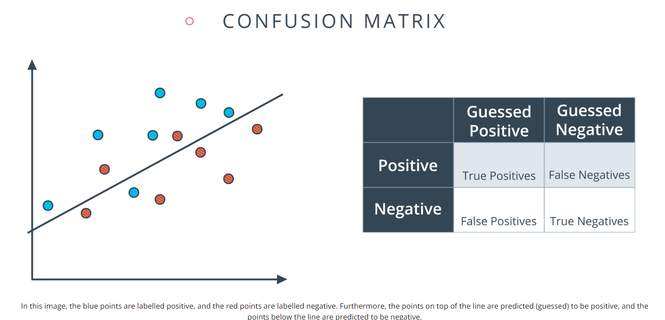

### 

### 

### Confusion Matrix Quiz

How many True Positives, True Negatives, False Positives, and False Negatives, are in the model above? Please enter your answer in that order, as four numbers separated by a comma and a space. For example, if your answers are 1, 2, 3, and 4, enter the string 1, 2, 3, 4.

Remember, in the image above the blue points are considered positives and the red points are considered negatives.

Answer: _________________________________________________________________

## Type 1 and Type 2 Errors

Sometimes in the literature, you'll see False Positives and False Negatives as Type 1 and Type 2 errors. Here is the correspondence:

* **Type 1 Error (Error of the first kind, or False Positive):** In the medical example, this is when we misdiagnose a healthy patient as sick.
* **Type 2 Error (Error of the second kind, or False Negative):** In the medical example, this is when we misdiagnose a sick patient as healthy.

The answer:

To determine the number of True Positives (TP), True Negatives (TN), False Positives (FP), and False Negatives (FN), let's analyze the given information step by step:

Blue points are labeled positive (actual positives).

Red points are labeled negative (actual negatives).

Points on top of the line are predicted as positive.

Points below the line are predicted as negative.

Definitions:

True Positives (TP): Actual positives (blue) correctly predicted as positive (on top of the line).

False Negatives (FN): Actual positives (blue) incorrectly predicted as negative (below the line).

False Positives (FP): Actual negatives (red) incorrectly predicted as positive (on top of the line).

True Negatives (TN): Actual negatives (red) correctly predicted as negative (below the line).

Counting the Points:

From the image (assuming the layout is as described):

True Positives (TP): Blue points on top of the line.

Count: 3

False Negatives (FN): Blue points below the line.

Count: 2

False Positives (FP): Red points on top of the line.

Count: 1

True Negatives (TN): Red points below the line.

Count: 2

Final Answer:

3, 2, 1, 2